Form validation with Dialog box and Checkbox
Workshop #4
Flutter Developer Bootcamp

Purpose
This workshop demonstrates how to implement basic form validation for Name and Email fields in a Flutter application using text controllers, regular expressions, and user interface components.

Problem
In the given workshop, there will be two text fields: Name and Email. You need to make the form validation work when the name is not entered, and if an invalid email address is entered. Additionally, add a checkbox for terms and conditions, and include a dialog box displaying the entered values for the name field, email field, and agreement to terms condition.

How to Solve
1. Checkout the workshop from Git Repo:
git clone -b <user-branch> <repo-URL>
2. Open the root folder inside VS Code
3. To build the app click the run option in the main method{}
4. Type an invalid Email in the field <textfield-name>
5. Click the Submit button, show a dialog box of field that have been entered in Name field, Email field and Agreed to terms condition.
6. Go To File: <specific-file-with-validation-method> à <method-name>, implement your validation logic. Make the validation work

You will Achieve
When you complete this workshop you will learn the following:
- Regex Validation: Learn how to use regular expressions to validate user input in text fields, ensuring that data entered by users meets specific criteria or formats.
- Text: Understand how to display textual content within your app's interface, including headings, paragraphs, labels, or other information.
- TextFormField: Implement text form fields for users to input text or data into your app, with built-in support for validation and formatting.
- Label Text: Incorporate label text alongside form fields to provide context or instructions to users, enhancing usability and clarity.
- Decoration: Explore techniques for applying decoration to widgets, such as text form fields or buttons, to enhance their visual appearance and style.
- Buttons: Integrate buttons into your app to trigger actions or navigate to different screens, improving user interactivity and navigation.
- Checkboxes: Add checkboxes to allow users to make selections or choices within your app, providing flexibility and customization options.
- Dialog Box: Utilize dialog boxes to display important messages, alerts, or prompts to users, improving user communication and interaction.
- Padding: Adjust spacing around widgets using the Padding widget to improve the layout and aesthetics of your app's user interface.
- SizedBox: Manage widget sizes and spacing within your app's layout using the SizedBox widget, providing flexibility and control over the layout's structure.
- Adjusting Text Alignment: Control the alignment of text elements within your app's interface to improve readability and visual consistency, enhancing the overall user experience.

Screenshots

Before implementation (without validation)
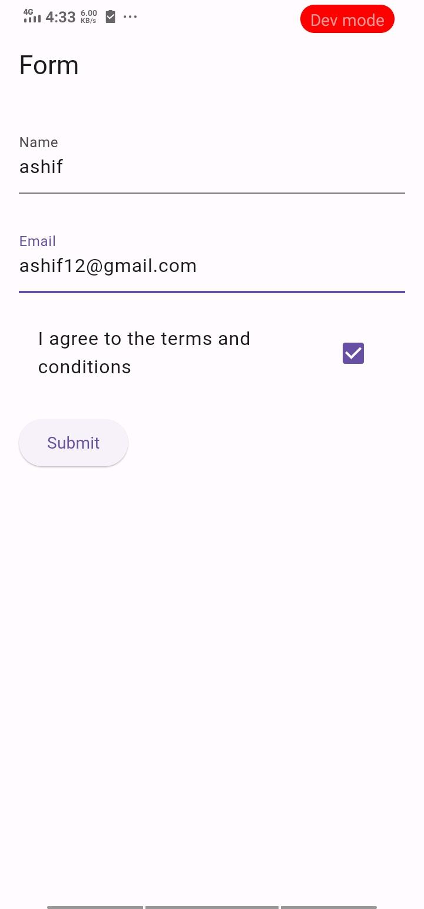

After implementation (With validation)
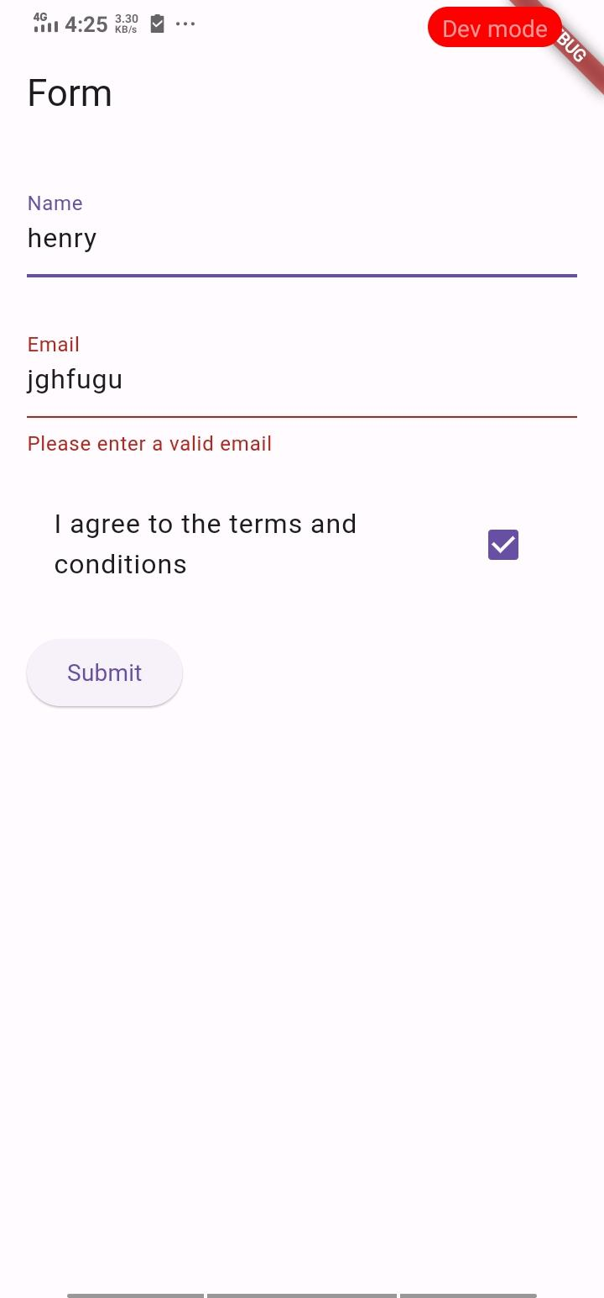
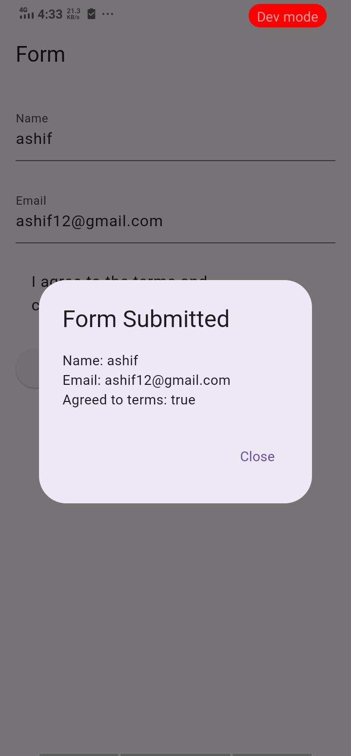

How to submit your workshop
Push your project back to the same git branch using command:
<command name>

Happy Coding!

